**SDF LAB WEEK 3**

**Q1**

**CODE**

**#include<stdio.h>**

**int main()**

**{**

**printf("hello world!!! \n \n");**

**printf("welcome here");**

**}**

**OUTPUT**

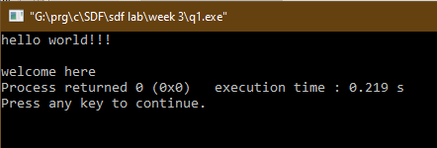

**Q2**

**#include<stdio.h>**

**int main()**

**{**

**float a,b,c;**

**printf("enter the values");**

**printf("\n enter the first value");**

**scanf("%f",&a);**

**printf("\n enter the second value");**

**scanf("%f",&b);**

**c=a+b;**

**printf("the sum of %0.1f and %0.1f is %0.1f",a,b,c);**

**return 0;**

**}**

**OUTPUT**

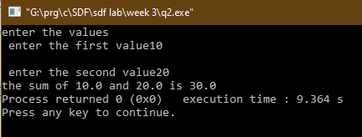

**Q3**

**CODE**

**#include<stdio.h>**

**int main()**

**{**

**float a,r;**

**printf("\n enter the value of radius of circle");**

**scanf("%f",&r);**

**a=3.14*(r*r);**

**printf("the area of circle of radius %0.2f is %0.2f",r,a);**

**return 0;**

**}**

**OUTPUT**

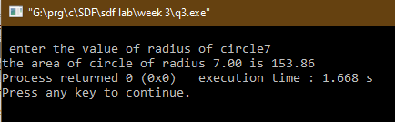

**Q4**

**CODE**

**#include<stdio.h>**

**int main()**

**{**

**float a,b,c,f,e,d,r;**

**printf("enter the values");**

**printf("\n enter the first value ");**

**scanf("%f",&a);**

**printf("\n enter the second value (value of second one < first one)");**

**scanf("%f",&b);**

**c=a+b;**

**printf("\n \n the sum of %0.1f and %0.1f is %0.1f",a,b,c);**

**d=a-b;**

**printf("\n \n the difference of %0.1f and %0.1f is %0.1f",a,b,d);**

**e=a*b;**

**printf(" \n \n the product of %0.1f and %0.1f is %0.1f",a,b,c);**

**f=a/b;**

**printf("\n \n the quotient of %0.1f devided by %0.1f is %0.1f",a,b,f);**

**return 0;**

**}**

**OUTPUT**

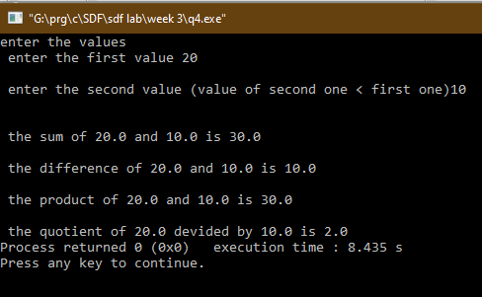

**Q5**

**CODE**

**#include<stdio.h>**

**void main()**

**{**

**float d1,a,q,r;**

**printf("enter the value of dividend");**

**scanf("%f",&d1);**

**printf("/n enter the value of divisor");**

**scanf("%f",&a);**

**q=d1/a;**

**printf("\n \n the quotient of %f devided by %f is %f",d1,a,q);**

**r=d1-(a*q);**

**printf("\n \n the remainder of %f devided by %f is %f",d1,a,r);**

**}**

**OUTPUT**

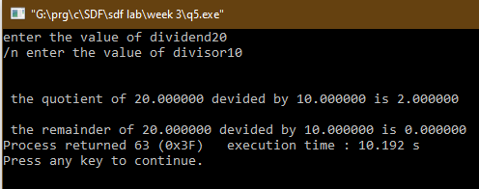

**Q6**

**CODE**

**#include<stdio.h>**

**void main()**

**{**

**float a=0,b=0;**

**printf("enter the first no");**

**scanf("%f",&a);**

**printf("enter the second no");**

**scanf("%f",&b);**

**a=a+b;**

**b=a-b;**

**a=a-b;**

**printf("the value of a is %f",a);**

**printf("the value of a is %f",b);**

**}**

**OUTPUT**

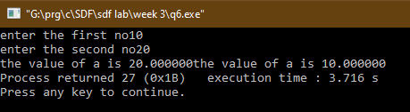

**Q7**

**CODE**

**#include<stdio.h>**

**void main()**

**{**

**int n=0,d=0,m=0;**

**printf("enter the numerator");**

**scanf("%d",&n);**

**printf("enter the denominator");**

**scanf("%d",&d);**

**printf(" the initial rational no is :- %d / %d", n,d);**

**printf(" \n %d / %d", n*2,d*2);**

**printf("\n %d / %d", n*3,d*3);**

**printf("\n %d / %d", n*4,d*4);**

**}**

**OUTPUT**

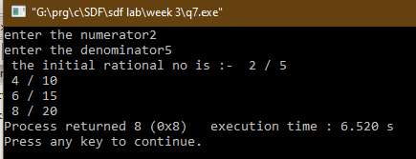

**Q8**

**CODE**

**#include<stdio.h>**

**#include<math.h>**

**void main()**

**{**

**float x1=0,y1=0,x2=0,y2=0,d1=0,d2=0,d3=0,D1,D2,D3,x3,y3;**

**printf("enter the value of x coordinate of first point");**

**scanf("%f",&x1);**

**printf("enter the value of y coordinate of first point");**

**scanf("%f",&y1);**

**printf("enter the value of x coordinate of second point");**

**scanf("%f",&x2);**

**printf("enter the value of y coordinate of second point");**

**scanf("%f",&y2);**

**printf("enter the value of y coordinate of second point");**

**scanf("%f",&x3);**

**printf("enter the value of y coordinate of second point");**

**scanf("%f",&y3);**

**printf("the points entere are P1 ( %f , %f ) , P2 ( %f , %f ), P3 ( %f , %f )",x1,y1,x2,y2,x3,y3);**

**D1 = ((x2-x1)*(x2-x1))+((y2-y1)*(y2-y1));**

**D2 = ((x3-x2)*(x3-x2))+((y3-y2)*(y3-y2));**

**D3 = ((x1-x3)*(x1-x3))+((y1-y3)*(y1-y3));**

**printf("\n \n \n the distance between P1 and P2 is %f", D1);**

**printf("\nthe distance is between P2 and P3 is %f", D2);**

**printf("\nthe distance is between P1 and P3 is %f", D3);**

**}**

**OUTPUT**

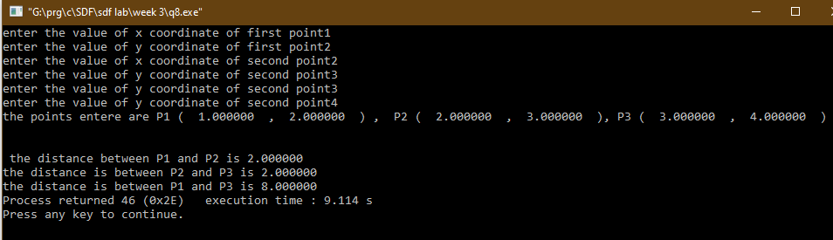

**Q9**

**CODE**

**#include<stdio.h>**

**// to do to do to do to do to do ussing operators**

**void main()**

**{**

**int a=0,b=1;**

**printf("logical table of AND:- \n \n \n");**

**printf("\n a n a && b");**

**printf("\n %d %d %d",a,a,a&&a);**

**printf("\n %d %d %d",a,b,a&&b);**

**printf("\n %d %d %d",b,a,a&&b);**

**printf("\n %d %d %d",b,b,b&&b);**

**printf("\n \n \n logical table of OR:- \n \n \n");**

**printf("\n a n a or b");**

**printf("\n %d %d %d",a,a,a||a);**

**printf("\n %d %d %d",a,b,b||a);**

**printf("\n %d %d %d",b,a,b||a);**

**printf("\n %d %d %d",b,b,b||b);**

**printf("\n \n \n logical table of NOT:- \n \n \n");**

**printf("\n a ~a ");**

**printf("\n ~ %d %d",a,!a);**

**printf("\n ~ %d %d \n \n \n ",b,!a);**

**}**

**OUTPUT**

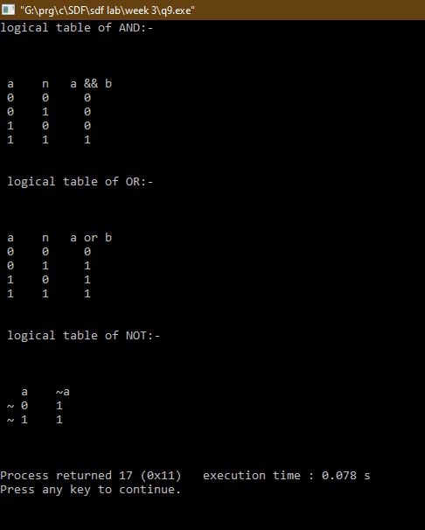

**Q10**

**CODE**

**#include<stdio.h>**

**void main()**

**{**

**int a,b,c,d,n=0;**

**printf("enter a 3 digit no :- ");**

**scanf("%d",&n);**

**a=n%10;**

**n=n/10;**

**b=n%10;**

**n=n/10;**

**c=n%10;**

**n=(a*100)+(b*10)+c;**

**printf("\n thte reversed no is :- %d",n);**

**}**

**OUTPUT**

